THE REAL NUMBER SYSTEM



Natural Numbers:

Whole Numbers:

Integers:

Rational Numbers:

Irrational Numbers:

Real Numbers:

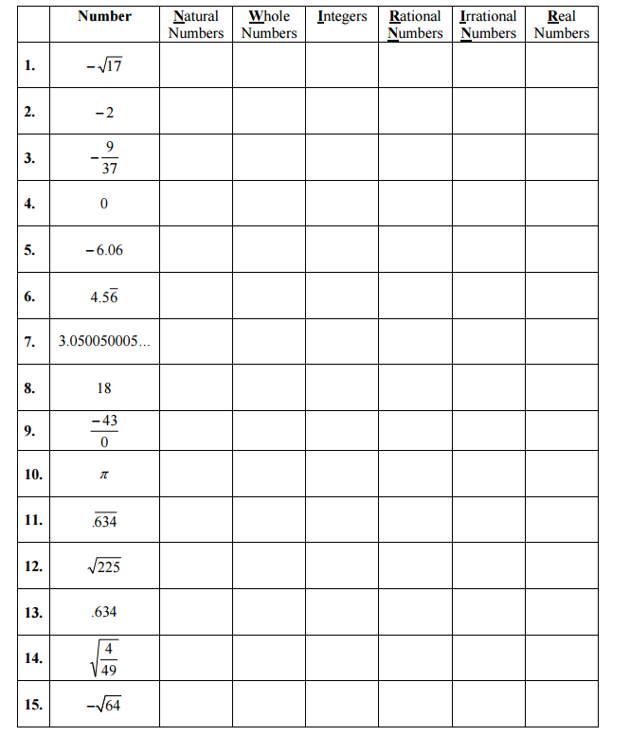

1. Your school is sponsoring a charity race. Which set of numbers does not contain the number of people *p* who participate in the race?
2. Natural numbers
3. Integers
4. Rational numbers
5. Irrational numbers

Ordering Numbers Based on Size

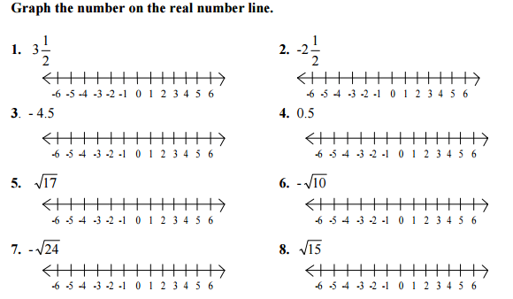

1. How do $\sqrt{17}$ and $3.8$ compare? Use $<$ or $>$
2. How do $\sqrt{26}$ and $6.25$ compare? Use $<$ or $>$
3. Let *a, b*, and *c* be real numbers such that *a < b* and *b < c*. How do *a* and *c* compare? Explain.

Problem Sets

1. What do the following mean?
2. Sum
3. Difference
4. Less than
5. Product
6. Quotient
7. Of
8. Answer **True** or **False** to the statements below. If false, explain why or provide a counter-example.
9. $-5$ is a rational number
10. 0 is an integer
11. $\sqrt{16}$ is a natural number
12. $-3.5\overline{73}$ is an integer
13. $\sqrt{8}$ is a rational number
14. $\sqrt{7}$ is a Real number
15. $18$ is a whole number
16. $-\frac{4}{7}$ is an integer
17. $2.434434443…$ is a rational number
18. $6.57$ is a ratioanl number
19. All fractions are rational numbers
20. All integers are whole numbers
21. All irrational numbers are Real numbers
22. All negative numbers are integer

Writing Expressions

Variable:

Algebraic expression:

1. Fill in the table below for the total number of pages Eve reads if she reads 25 pages per hour

|  |  |  |  |  |  |
| --- | --- | --- | --- | --- | --- |
| Hours | 1 hour | 2 hours | 3 hours | 4 hours | 20 hours |
| Pages Read |  |  |  |  |  |

1. Write an expression for the number of pages she reads in $h$ hours.
2. Sam is 2 years younger than Sue, who is $y$ years old. Write an expression for Sam’s age
3. Lou drives at $30$ mi/h. write an expression for the number of miles that Lou drives in $t$ hours.
4. You start with $20 and save $5 per week. Write an algebraic expression that models the total amount you save in $w$ weeks
5. You had $150, but you’re spending $\$2$ per day. Write an algebraic expression that models the total amount you have in $d$ days.

Evaluating Expressions

1. What does the word “evaluate” mean?
2. What is the value of the expressions for the given values of the variables?
3. $7\left(a+4\right)+3b-8$ for $a= -4$ and $b=5$
4. $\frac{x}{2}+y^{2}$ for $x=1$ and $y=\frac{1}{2}$
5. $\frac{2\left(x^{2}-y^{2}\right)}{3}$ for $x=6$ and $y= -3$

Simplifying Algebra Expressions

1. Combine the like terms for $3x^{2}+5x^{2}+9y^{3}z+2yz-4y^{3}z$
2. Combine like terms

$7x^{2}+3y^{2}+2y^{2}-4x^{2}$

$-\left(3k+m\right)+2(k-4m)$

$-4x^{2}-7y+5x+x^{2}$

$-\left(8a+3b\right)+10\left(2a-5b\right)$

Problem Sets

1. Simplify by combining like terms
$5a-a$

$2a+3b+4a$

$7b-\left(3a-8b\right)$

$6x+3y+7y+4x$

$5+\left(4x-7\right)$

$-5x-x+y$

$5.5x+0.5x$

$-a^{2}+2b^{2}+5a^{2}$

$x\left(3-y\right)+y\left(x+6\right)$

$7\left(x^{2}-y^{2}\right)-5\left(x^{2}-y^{2}\right)$

2. Evaluate each expression for the given value of the variable
$x+2x-x-1 for x=2$

3. $3r+5+7-9r$ for $r= -3$
4. $2\left(3a+5\right)+2\left(3-a\right)$ for $a=4$
5. $\frac{5\left(2k-3\right)-3\left(k+4\right)}{3k+2}$ for $k=-2$
6. Wriute an algerbaic expression
7. 9 less than k
8. Six times the daily amount of fiber $f$ in your diet
9. The total number of seashells $s$ divided by 10
10. 4 more than twice x
11. For a walk-a-thon a sponsoir commited to give you a flat fee of $5 plus $3 for every mile $m$ you walk.
12. Write an expression for the total amount you will collect from your sponser at the end of the walk-a-thon
13. How much will you get for 30 miles walked?